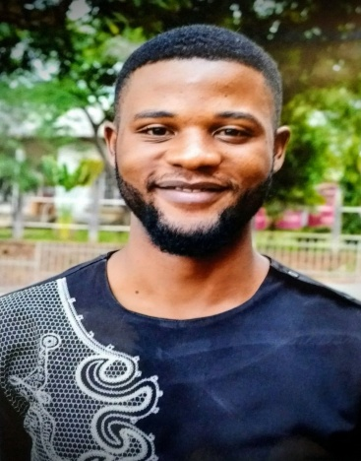
What activities did you participate in during your YES year, or what skills did you learn, that you have used to improve your home country or community? How have you built on those skills since returning home? Please give specific examples.

A major goal of the YES Program is that students share the knowledge and skills they gained in the U.S. when they get back to their home countries as YES alumni. I am about to share with you my experience as far as this goal is concerned.
My year in the U.S.A as an exchange student was the first year I got exposed to the notion of “Volunteerism.” During this year, I had the opportunity to volunteer for many organizations such as Habitat for Humanity, Eden Boys and Girls Club, Community churches, Schools, Fire fighters office and many other places. In the ten months I spent in the United States, I was able to complete over 100 hours of Community service and it got me recognition for outstanding volunteer service from the United States Department of State.
Back in my home country as a YES alumnus, I applied for and won the 2014 YES small grant to implement an environmental project – Saving Our Environment Project – in my community in Bonaberi, Douala. This project was able to mobilise all the youths in my community for our environmental protection, and it received special acknowledgement and encouragement from the community leaders.
The following year (in 2015), I was able to raise funds to give an American Christmas experience to over 60 kids in my community.
In addition to the numerous impactful projects I was able to implement upon my return to Cameroon from my exchange year, I was equally able to share the skills I gained through the implementation of many training workshops such as:
- Mastering the Arts of Public speaking
- Leadership training workshop
- Project Management in Practice Workshop
- Etc.
All these activities, coupled with my academic accomplishments and capacity-building trainings I received subsequently, helped me strengthen my leadership and communication skills as well as many other skills.

